**EMG and IMU Data for Therapy Mapping**

#### **Problem Statement**

With an estimated 300 million physical therapy sessions conducted every year, the practice is constantly evolving, improving, and changing the lives of over 50 million patients. There however is a gap between connection between therapists and technical engineers resulting in a lack of technology use by physical therapists. While therapists are able to feel improvement in their patients’ muscles and patients observe improvement in their own function, there is no technological way to quantify muscle improvement over the course of therapeutic treatment for empirical measurement of improvement.

#### **Proposed Solution**

We propose the development of an EMG and IMU sleeve that can be quickly placed on a patient’s arm that will provide accurate muscle tracking data in order to measure change (hopefully improvement) in muscle strength and function across each therapy session. The proposed system will include:

* EMG and IMU Sensor Sleeve: A comfortable, adjustable sleeve capable of capturing real-time EMG data with high fidelity. Must collect on an array of positions along the arm or hands and not interfere with movement.
* Signal Processing Module: Software algorithms to analyze EMG data, identifying specific patterns associated with different movements. Ability to specify movements quickly for label matching. Ability to create plots of muscles from day to day.
* User Customization Tools: An interface for users to therapists to determine effectiveness of certain therapy techniques, share improvement with different patients, track other data (questionnaire based)

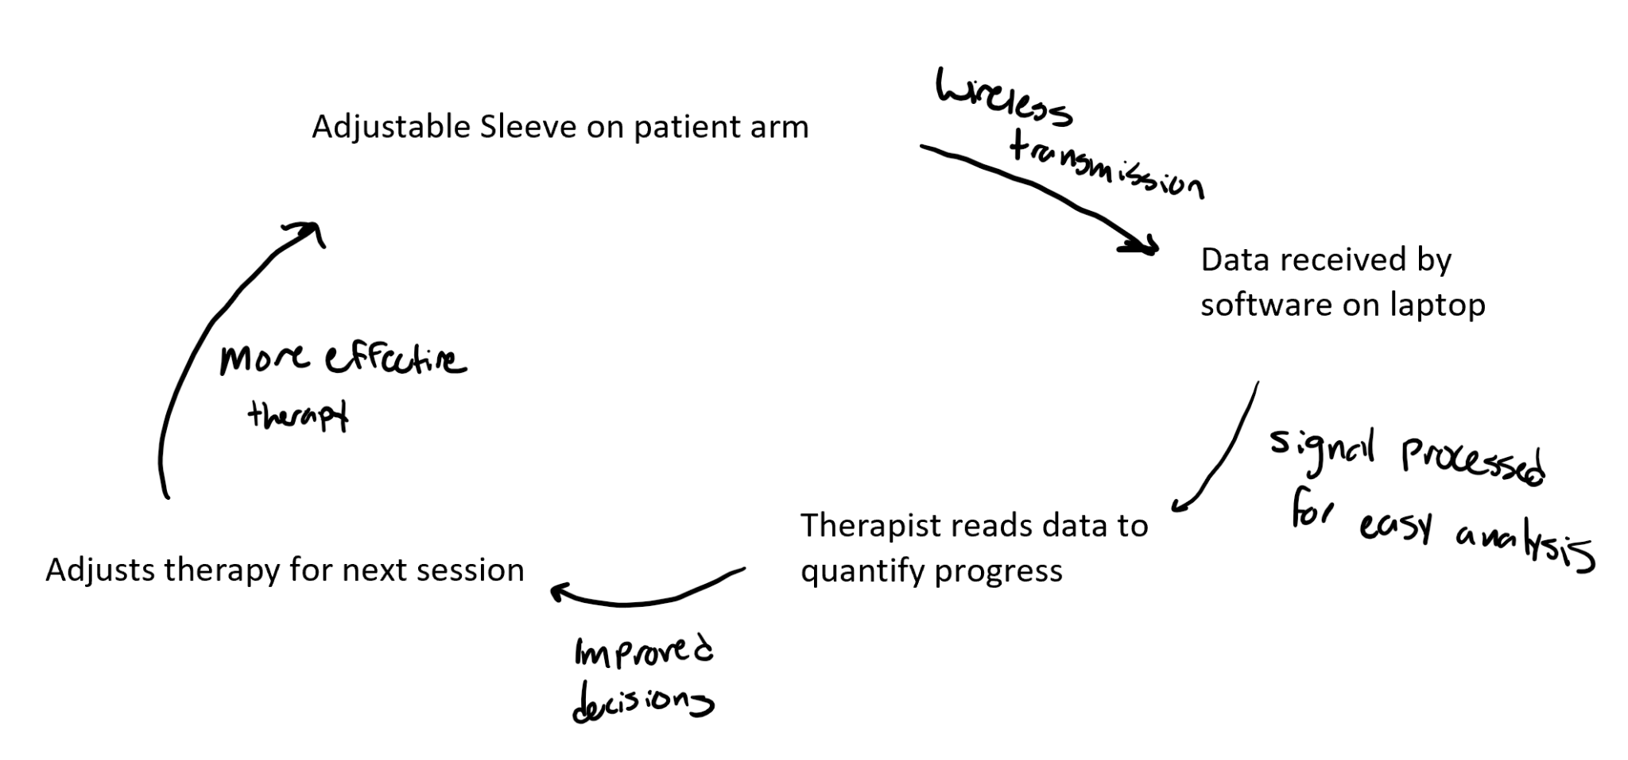

#### **Target Users**

The EMG/IMU Sleeve aims to serve the specific people engaging in upper extremity physical therapy including:

* Individuals with Disabilities or Injuries: Slightly changes therapeutic experience in order to provide peace of mind through quantifiable measurement of improvement. Allows for better treatment based on this data analysis.
* Educators and Therapists: Providing a tool for biofeedback for therapy in order to improve ability to provide specific targeted therapy for some muscles. Gives quantifiable results and tracks progress in one system
* General Public: Anyone interested in biofeedback, personalization, and innovative technology interfaces.

#### **Potential Impact**

The introduction of a EMG/IMU Sleeve has the potential to significantly impact various fields:

* Inclusivity in Technology: Making technology more accessible to people with physical disabilities and improving the lives of those that want treatments.
* Advancements in Biofeedback for Therapy: Offering a novel tool for therapists, enhancing treatments focused on improving muscle strengths.
* Time Saving and Market Changes: There is an estimated $45 billion market for physical therapy in the US meaning that there is direct impact to this. Some patients attend therapy 7 days per week meaning improving therapy could lead to less sessions and higher quality of life.

#### **Considerations, Risks, and Questions**

* Privacy and Security: Ensuring that sensitive EMG data is securely handled and that users' muscle information remains between them and their therapist. If additional questioning is stored in our software then that also needs to be kept private
* Accessibility and Affordability: School to be a physical therapist is quite expensive so a device that has reliable collection of EMG and IMU data may be a challenge to make affordable (or this cost is relatively low compared to PT school). May make therapists charge more for their treatment to make back the investment of a sleeve.
* User Experience: Designing an intuitive and user-friendly interface that accommodates a wide range of preferences and needs.
* Technical Challenges: Addressing the complexities of accurately interpreting and collecting EMG signals and translating them into meaningful data for feedback to the therapist
* Market Acceptance: Assessing whether there is sufficient interest and willingness among potential users to adopt this new form of interaction.